***Electronic Engineering Fundamentals - Assignment 1***

*Exercise 1*

Differentiate between Thevenin’s and Norton’s Theorem (including example of circuit).

**Sol.**

***Davenning's theorem says that we can convert a circuit other than a load circuit into an equivalent circuit with a single voltage source and series resistance.（As shown in figure 1）***

***Norton's theorem means that we can convert a branch circuit other than a load circuit into an equivalent circuit with a single current source and parallel resistance. （As shown in figure 2）***

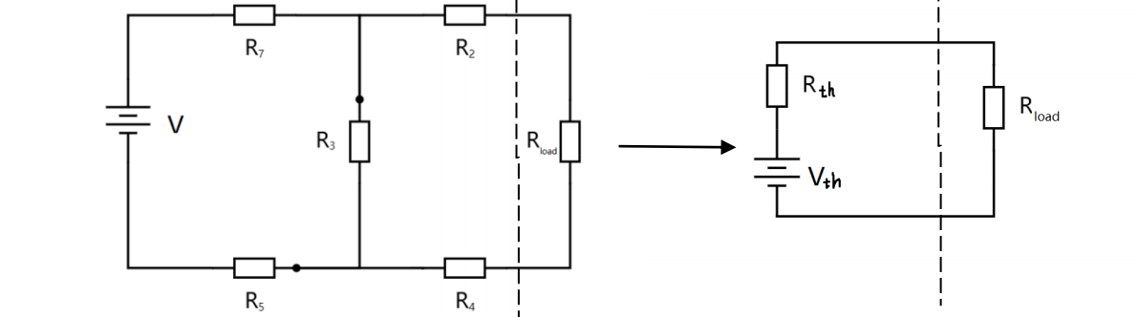1

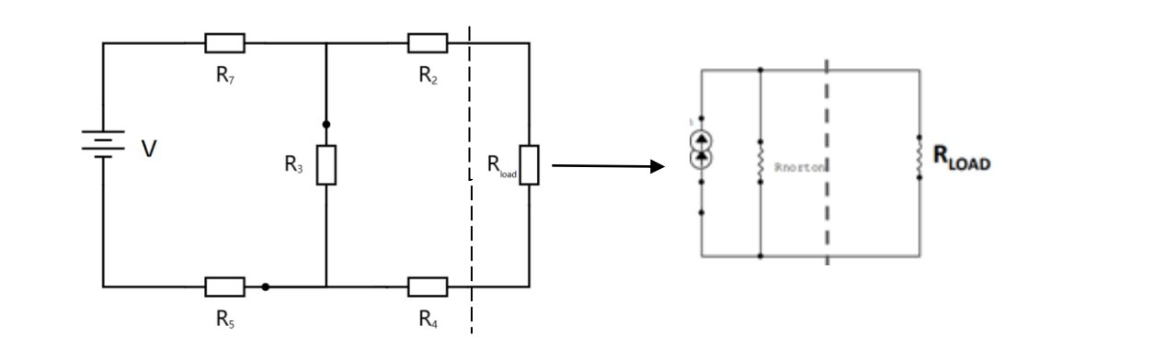2

# Exercise 2

1. Calculate **the Norton’s equivalent circuit** for the indicated section (left-hand-side of the divider) of the circuit below.
2. Calculate the **Thevenin’s equivalent circuit** for the indicated section (left-handside of the divider) of the circuit below.
3. Calculate the current that will flow through RL if RL =100 Ω.

**9**

**V**

**6**

**Ω**

**+**

**-**

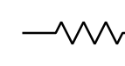

**3**

**Ω**

**R**

**L**



**Sol 1**

**I (Norton)= 9𝑉/3𝛺 =3A**

**R(Norton)= 3𝛺∗6𝛺 /(3𝛺+6𝛺) =2Ω**

**Sol 2**

**V (Thevenin)=𝟗𝑽 ∗ { 𝟔Ω /（𝟑Ω+6Ω）} = 6 V**

**R (Thevenin) = 3Ω∗6Ω/(3Ω+6Ω) = 2Ω**

**Sol 3**

**By the Thevenin’s equivalent circuit**

**I（L）= V 𝐓𝐡𝐞𝐯𝐞𝐧𝐢𝐧/(R 𝐓𝐡𝐞𝐯𝐞𝐧𝐢𝐧+ R L) = 6𝑉/(100Ω+2Ω) ≈0.06A**

# Exercise 3

State Coulomb’s Law. A sphere containing 5*10-6 Coulombs of positive electrical charge is placed 2 metres away from an infinitely large negatively charged plate. The plate generates a uniform electric field of value 30 N/C perpendicular to the plate. State the magnitude and direction of the force (towards the plate or away from it) experienced by the sphere.

**Sol.**

$F=E*q=5*{10}^{-6}C*\frac{30N}{C}=1.5*{10}^{-5}$ N

# Exercise 4

What current will flow through each of the resistors in the circuit shown below? Calculate also the power lost in each resistor.

***Moodle Turn***

***-***

***it***

***-***

***in will be used.***

**Reports with high**

**similarity scores will be heavily**

**penalised.**

**(**

**i.e. you copied or were copied**

**-**

**it doesn't matter which).**

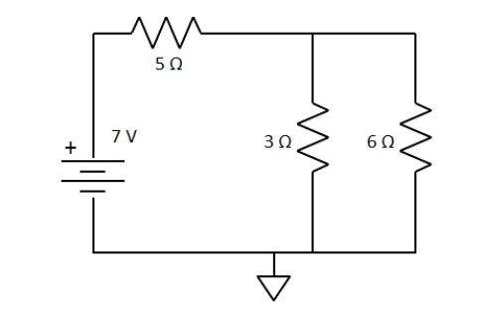

**Sol.**

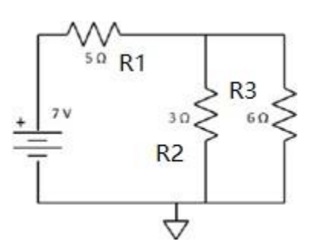

By the question,we get:

$I_{1}=\frac{E}{\{R1+\frac{R2*R3}{R2+R3}\}}$ =1A

∵ $I_{1}=I_{2}+I_{3}$ and $\frac{I2}{I3}=\frac{R3}{R2}$

∴ $I_{2}$ =0.67A $; I_{3}$ =0.33 A

$P_{1}=\frac{{(U_{1})}^{2}}{R1}$ = 5.00 w

$P_{2}=\frac{{(U_{2})}^{2}}{R2}$ = 1.35 w

$P_{3}=\frac{{(U_{3})}^{2}}{R3}$ = 0.65 w